**CHAPTER 1**

**INTRODUCTION**

**1.1 Introduction**

* The brief introduction of the project work is described here such as definitions, terminology etc.
* Problem statement should be described/defined at the end.

The figures in the text represented as, connection of different devices and block diagram of IOT eco system is shown in figure 1.1 and 1.2 respectively.

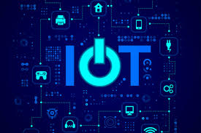

**Fig. 1.1** Connecting different devices using IOT

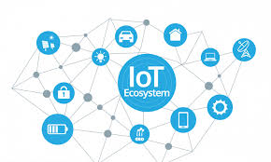

**Fig. 1.2** Block diagram of IOT eco system

**1.2 Objective of the Project**

* At least one objective should be given related to project title.

For Example:

1. To develop online portal for guiding patients in health monitoring system.

(or)

1. To investigate the health diseases using artificial intelligent system.

**1.3 Applications**

* Applications of your project should be given.

**1.4 Literature Survey**

Related work/previous work should be described with references as given below.

The term Internet of Things was first coined by Kevin Ashton in 1999 in the context of supply chain management. However, in the past decade, the definition has been more specified covering a wide range of applications like healthcare, utilities, transport, etc. Although the definition of „Things‟ has changed as technology evolved, the main goal of making a computer sense information without the aid of human effort remains the same **(Jayavardhana and Ram,2018)**.

**Jhon and Samuel (2019)**, have brought a radical evolution of the current Internet system into a Network of interconnected the objects that not only gathering the information from the environment (sensing) and interacts with the physical world, but also uses existing Internet standards to provide services for information transfer, analytics, applications and communications.

**CHAPTER 2**

**DESIGN AND ANALYSIS**

**2.1 Methodology**

Here, step by step procedure must be given for completion of project work.

Table representation as follows, power Consumption of different types of sensorare given inTable 2.1

# Table 2.1 Power Consumption of different types of sensor

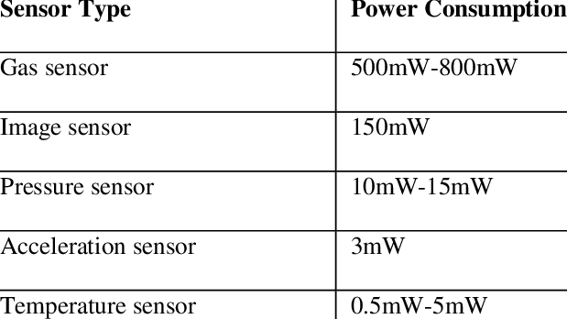

**2.2. Software and Hardware Requirements**

A brief description of software and hardware requirements are to be given like versions, features and usage

**2.3 Flow Chart**

A flow chart should be drawn for representing methodology of project work. It includes control flow of project work. A separate flow charts can be drawn for each module if necessary.

**CHAPTER 3**

**IMPLEMENTATION**

**3.1 Module-1**

Detailed explanation of module 1 with figures and tables if possible

**3.2 Module-2**

Detailed explanation of module 2 with figures and tables if possible

**3.3 Module-3**

Detailed explanation of module 3 with figures and tables if possible

**Note:** There is no restriction on count of number of modules**.**

**CHAPTER 4**

**TESTING AND RESULTS**

Here, detailed explanation of execution of modules and their respected results are given with help of figures and tables if possible.

**CHAPTER 5**

**CONCLUSIONS**

**5.1 Conclusions**

Conclusions will be drawn from given project work and listed as follows

1. Conclusion-1

2. Conclusion-2 etc.

**5.2 Future Scope of Work**

Enhancement of project work should be given like **“objectives”**

**REFERENCES**

1. Jayavardhana and Ram (2018), "Internet of Things (IoT): A vision, architectural elements, and future directions." Future Generation Computer Systems 29.7,1645-1660.
2. John and Samuel (2019). "Research directions for the internet of things." Internet of Things Journal, IEEE 1.1,3-9.

**Note: Do not write the following reference**

1. <https://www.google.com/>
2. <https://www.wikipedia.org/>

**APPENDIX-1**

**SOURCE CODE**

* Sample code (Not full code) for each module should be given.
* It should not exceed more than 2 pages for each module.

**APPENDIX-2**

**DATA BASE INFORMATION**

The data base information should be given.

* Number of tables, input parameters/variables and their type etc.
* Sample table data (2 or 3 records for each table) should be given instead of screen shots of tables.

**APPENDIX-3**

**SCREENSHOTS OF OUTPUTS**

* Other screen shots f results which are not mentioned in the project report.
* It should not exceed more than 2 pages.